LeetCode Program 2739
Link :- https://leetcode.com/problems/total-distance-traveled/
Successful Submission
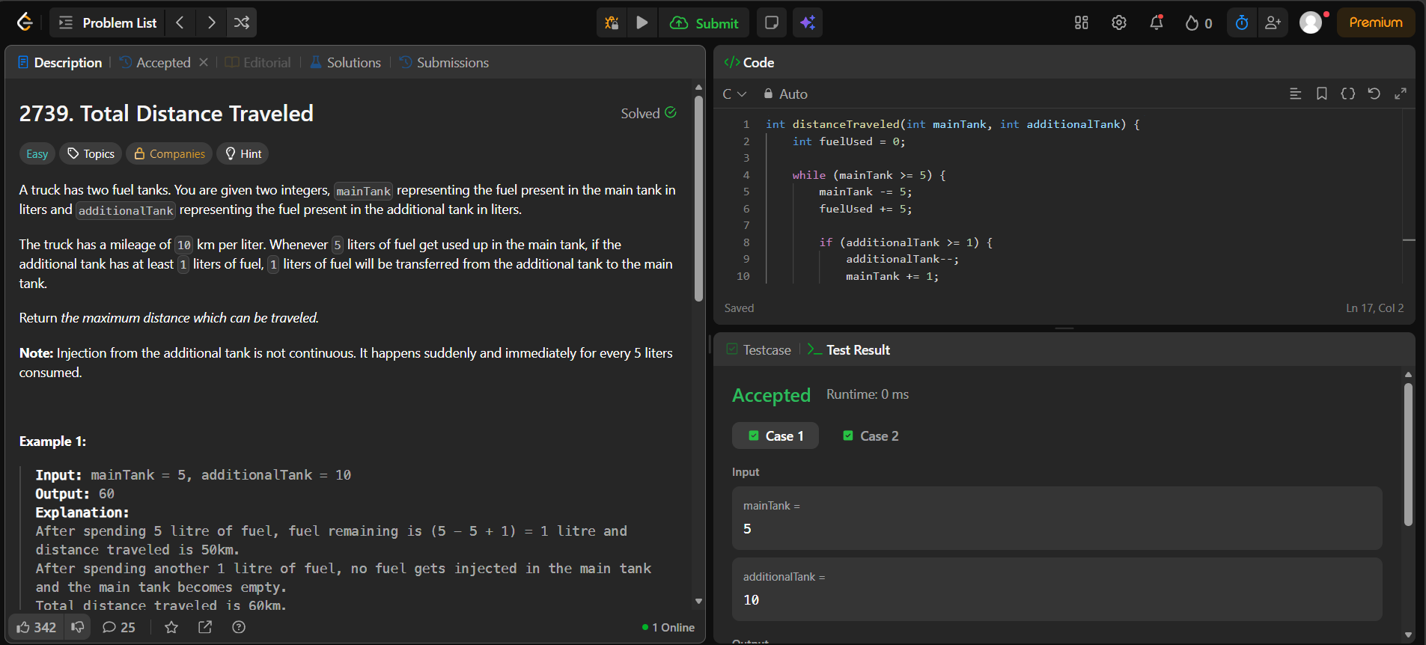
Source Code


